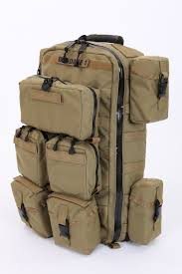
This document has been modified from its original version. Document Courtesy of NASA
Object | Cost | Mass(kg)
- Oxygen Tank with Mask | $4 | 3 kg
- IPad with movies | $1 | 0.6 kg
- Musical instrument (guitar) | $6 | 1 kg
- Blood Pressure Cuff & Monitor | $2 | 1 kg
- Digital Camera | $1 | 0.5 kg
- Epinephrine (EpiPen)- 5 count | $5 | 0.2 kg
- AED (Automated External Defibrillator) | $6 | 1.4 kg
- IV Equipment with fluids | $3 | 2 kg
- Pictures of friends/family | $0.50 | 0.6 kg
- Blood Oximeter (Blood Oxygen) | $4 | 0.3 kg
- Diazepam: treats anxiety, muscle spasms, and seizures | $4 | 0.1 kg
- Stethoscope | $3 | 0.2 kg
- Your favorite book | $2 | 0.5 kg
- Albuterol (Inhaler)- 5 count | $4 | 0.2 kg
- LED Headlamp | $2 | 2 kg
- Dental Kit | $5 | 0.6 kg
- Ibuprofen/ Acetaminophen | $3 | 0.1 kg
- General Antibiotics | $2 | 0.2 kg
- Mirror | $1 | 0.5 kg
- Thermal blanket | $3 | 1 kg

